LINEAR (BUS-STYLE)
SWITCHED NETWORK TOPOLOGY
Configuration, VLAN Verification, and End-to-End Connectivity Test
Cisco Packet Tracer Lab Report | September 10, 2026
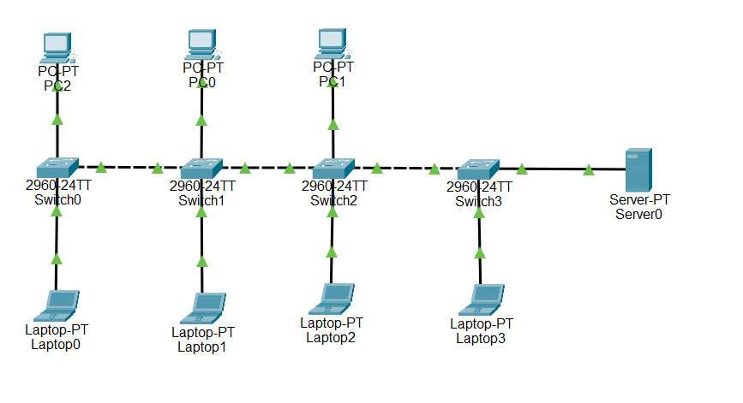
Figure 1. Linear switched topology with four Cisco 2960 switches, seven workstations, and one server.
Lab outcome: All active switch links were placed in VLAN 10 (BUSNETWORK), and PC2 successfully reached multiple hosts - including the server at the far end of the switch chain - with 0% packet loss.

Purpose: demonstrate Layer 2 switching, VLAN membership, switch-port verification, and ICMP connectivity across a multi-switch LAN.

1. Objective and Network Design
Objective. Building a linearly connected Ethernet LAN in Cisco Packet Tracer. The lab uses four Cisco 2960 switches connected in sequence. End devices are attached along the chain, and all active interfaces are assigned to a common VLAN so the hosts can communicate at Layer 2.
Topology classification: The diagram is a modern linear or daisy-chained switched topology. It is bus-style in its visual arrangement, but unlike a legacy shared coaxial bus, each Ethernet link is a point-to-point switch connection.

1.1 Device Inventory
Device Type | Quantity | Examples | Role
Cisco 2960-24TT switch | 4 | Switch0-Switch3 | Layer 2 forwarding and VLAN membership
PC | 3 | PC2, PC0, PC1 | Client/end-host connectivity testing
Laptop | 4 | Laptop0-Laptop3 | Client/end-host connectivity testing
Server | 1 | Server0 | End-to-end destination host

1.2 Logical Addressing Plan
All hosts use the 192.168.10.0/24 network. No default gateway is required for these tests because the traffic remains within a single IP subnet and no router is present.
Device | IPv4 Address | Subnet Mask | VLAN
PC2 | 192.168.10.10 | 255.255.255.0 | 10
Laptop0 | 192.168.10.20 | 255.255.255.0 | 10
PC0 | 192.168.10.30 | 255.255.255.0 | 10
Laptop1 | 192.168.10.40 | 255.255.255.0 | 10
PC1 | 192.168.10.50 | 255.255.255.0 | 10
Laptop2 | 192.168.10.60 | 255.255.255.0 | 10
Laptop3 | 192.168.10.70 | 255.255.255.0 | 10
Server0 | 192.168.10.100 | 255.255.255.0 | 10

1.3 VLAN Design
VLAN 10 - BUS_NETWORK was created on each switch. In this single-VLAN lab, the used ports - including the inter-switch links - were assigned as access ports in VLAN 10. This keeps the Layer 2 path consistent from Switch0 through Switch3.
vlan 10
name BUS_NETWORK
!
interface <used-port>
switchport mode access
switchport access vlan 10

2. Switch Configuration Verification
The switch CLI output was checked with show interfaces status. The screenshots below verify that the connected FastEthernet interfaces are active, operating at 100 Mb/s, and assigned to VLAN 10.
Switch | Connected Ports Observed | VLAN | Verification
Switch0 | Fa0/1-Fa0/3 | 10 | Connected ports shown in VLAN 10
Switch1 | Fa0/1-Fa0/4 | 10 | All four connected ports in VLAN 10
Switch2 | Fa0/1-Fa0/4 | 10 | All four connected ports in VLAN 10
Switch3 | Fa0/1-Fa0/3 | 10 | Connected ports shown in VLAN 10

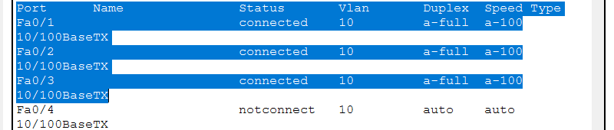  Figure 2. Switch0 interface-status verification. | 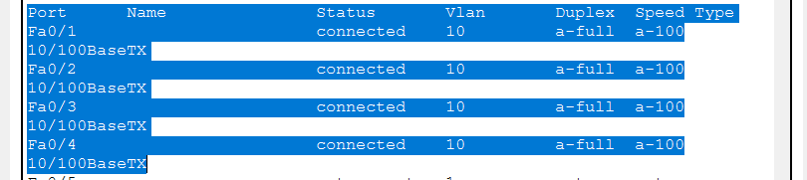  Figure 3. Switch1 interface-status verification.
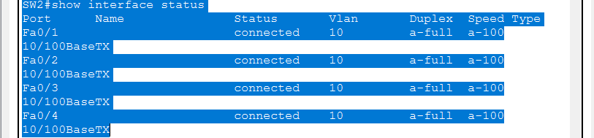  Figure 4. Switch2 interface-status verification. | 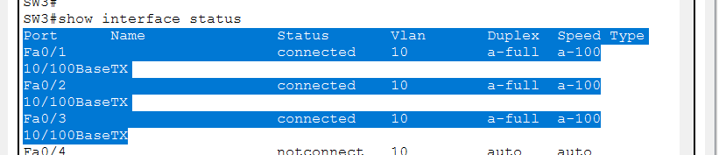  Figure 5. Switch3 interface-status verification.
Configuration note: A temporary VLAN mismatch can appear while switches are being configured one at a time. The condition is resolved when both ends of each inter-switch connection are assigned consistently to VLAN 10.

3. Connectivity Testing and Results
PC2 was used as the primary test host. Its IPv4 configuration shows 192.168.10.10/24. ICMP echo requests were then sent to progressively more distant devices to verify forwarding through the switch chain.

3.1 Ping Test Evidence
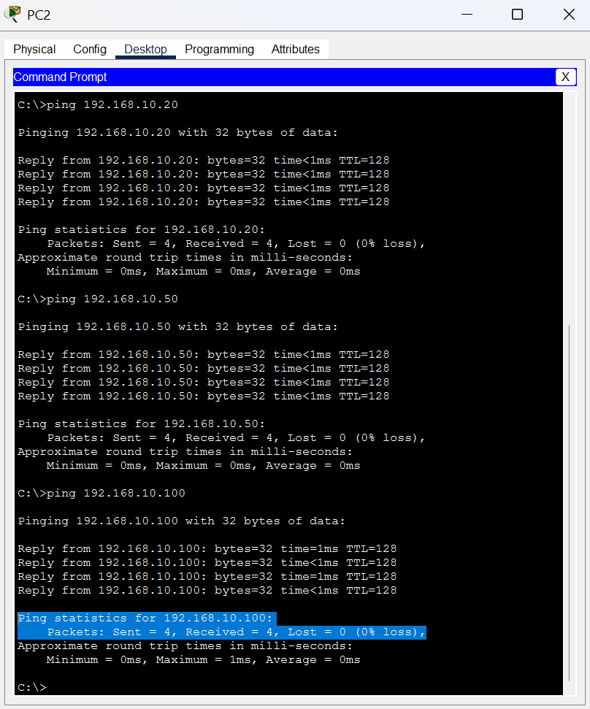
Figure 6. PC2 successfully pings 192.168.10.20, 192.168.10.50, and 192.168.10.100.

3.2 Test Results
Source | Destination | Purpose | Packet Result | Status
PC2  192.168.10.10 | Laptop0  192.168.10.20 | Local/near-side host test | 4 sent, 4 received  0% loss | PASS
PC2  192.168.10.10 | PC1  192.168.10.50 | Multi-switch client test | 4 sent, 4 received  0% loss | PASS
PC2  192.168.10.10 | Server0  192.168.10.100 | End-to-end chain test | 4 sent, 4 received  0% loss | PASS

3.3 Interpretation
- 0% packet loss confirms successful IPv4 communication from PC2 to each tested destination.
- The Server0 test verifies the complete Layer 2 path across Switch0, Switch1, Switch2, and Switch3.
- The successful tests confirm consistent VLAN 10 membership across the active forwarding path.
- All tested hosts are in one /24 subnet, so no router or default gateway is required for these tests.
Conclusion: The linear switched LAN was configured successfully. VLAN 10 (BUS_NETWORK) provided a common Layer 2 broadcast domain across the four-switch chain, and the successful ICMP tests - including PC2 to Server0 - confirmed end-to-end connectivity with no packet loss.

