CISCO PACKET TRACER LAB REPORT
Switched Ethernet Star Topology
Layer 2 redundancy, Rapid PVST+, root bridge selection, and ICMP verification
Lab objective: Building and verifying a partial-mesh Ethernet topology in Cisco Packet Tracer. The lab demonstrates redundant Layer 2 paths, Rapid PVST+ loop prevention, deliberate root bridge selection, static IPv4 addressing, and end-to-end ping testing.

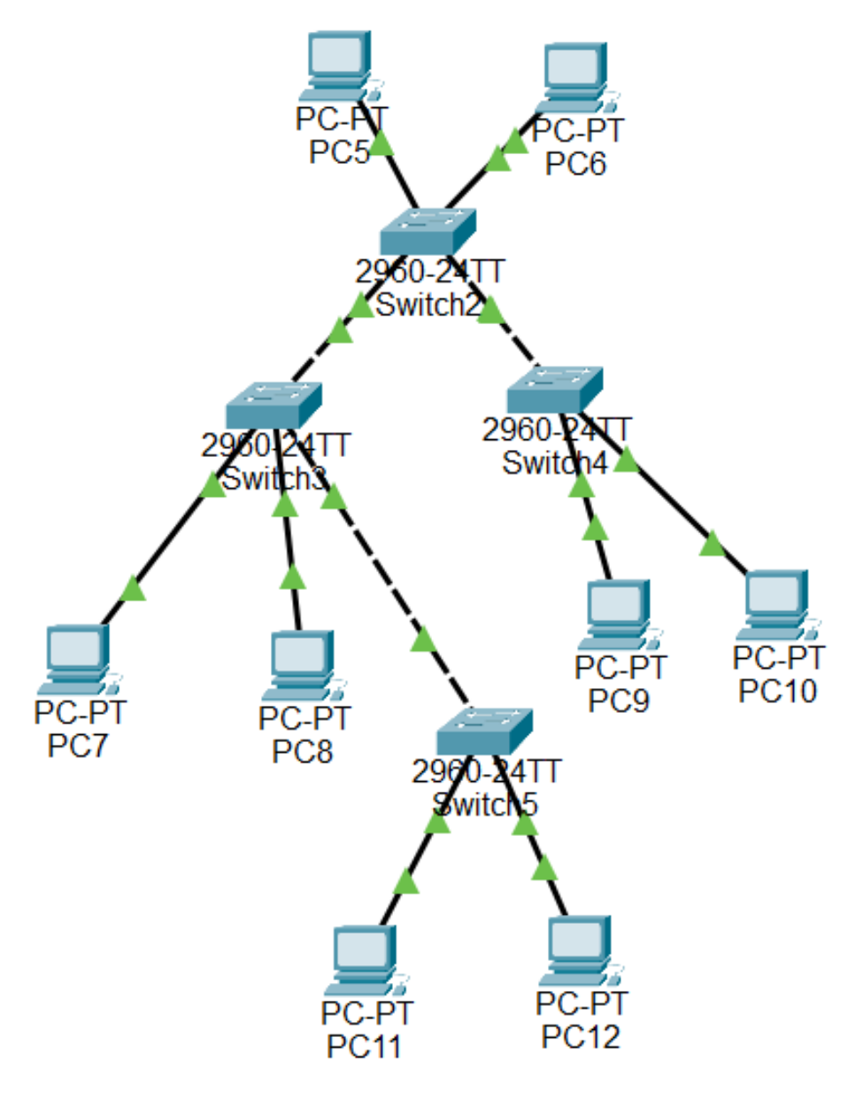
Figure 1. Completed partial-mesh topology using four Cisco 2960-24TT switches and eight PC-PT endpoints.
The switch fabric uses five inter-switch links. A full mesh of four switches would require six links, so the absence of a direct Switch2-to-Switch5 connection makes this a partial mesh rather than a full mesh.
The redundant paths create the possibility of a Layer 2 switching loop. Rapid PVST+ is therefore used to maintain a loop-free forwarding topology while preserving alternate paths.

1. Network Design and IPv4 Addressing
All end devices are configured in the same IPv4 subnet so the lab can focus on Layer 2 switching and spanning-tree behavior. No router is shown in the topology, so a default gateway is not required for communication within this subnet.
Device | IPv4 Address | Subnet Mask | Default Gateway
PC5 | 192.168.10.5 | 255.255.255.0 (/24) | None / 0.0.0.0
PC6 | 192.168.10.6 | 255.255.255.0 (/24) | None / 0.0.0.0
PC7 | 192.168.10.7 | 255.255.255.0 (/24) | None / 0.0.0.0
PC8 | 192.168.10.8 | 255.255.255.0 (/24) | None / 0.0.0.0
PC9 | 192.168.10.9 | 255.255.255.0 (/24) | None / 0.0.0.0
PC10 | 192.168.10.10 | 255.255.255.0 (/24) | None / 0.0.0.0
PC11 | 192.168.10.11 | 255.255.255.0 (/24) | None / 0.0.0.0
PC12 | 192.168.10.12 | 255.255.255.0 (/24) | None / 0.0.0.0

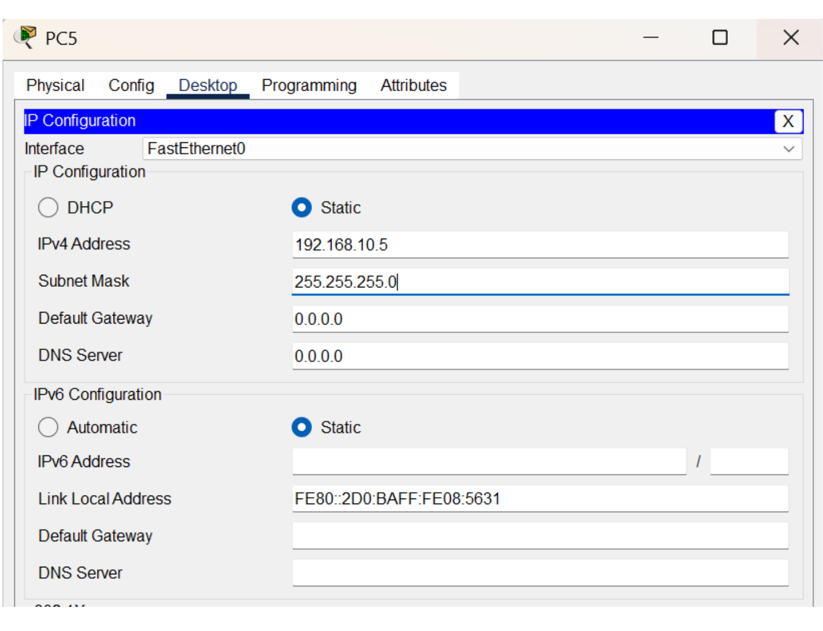 | 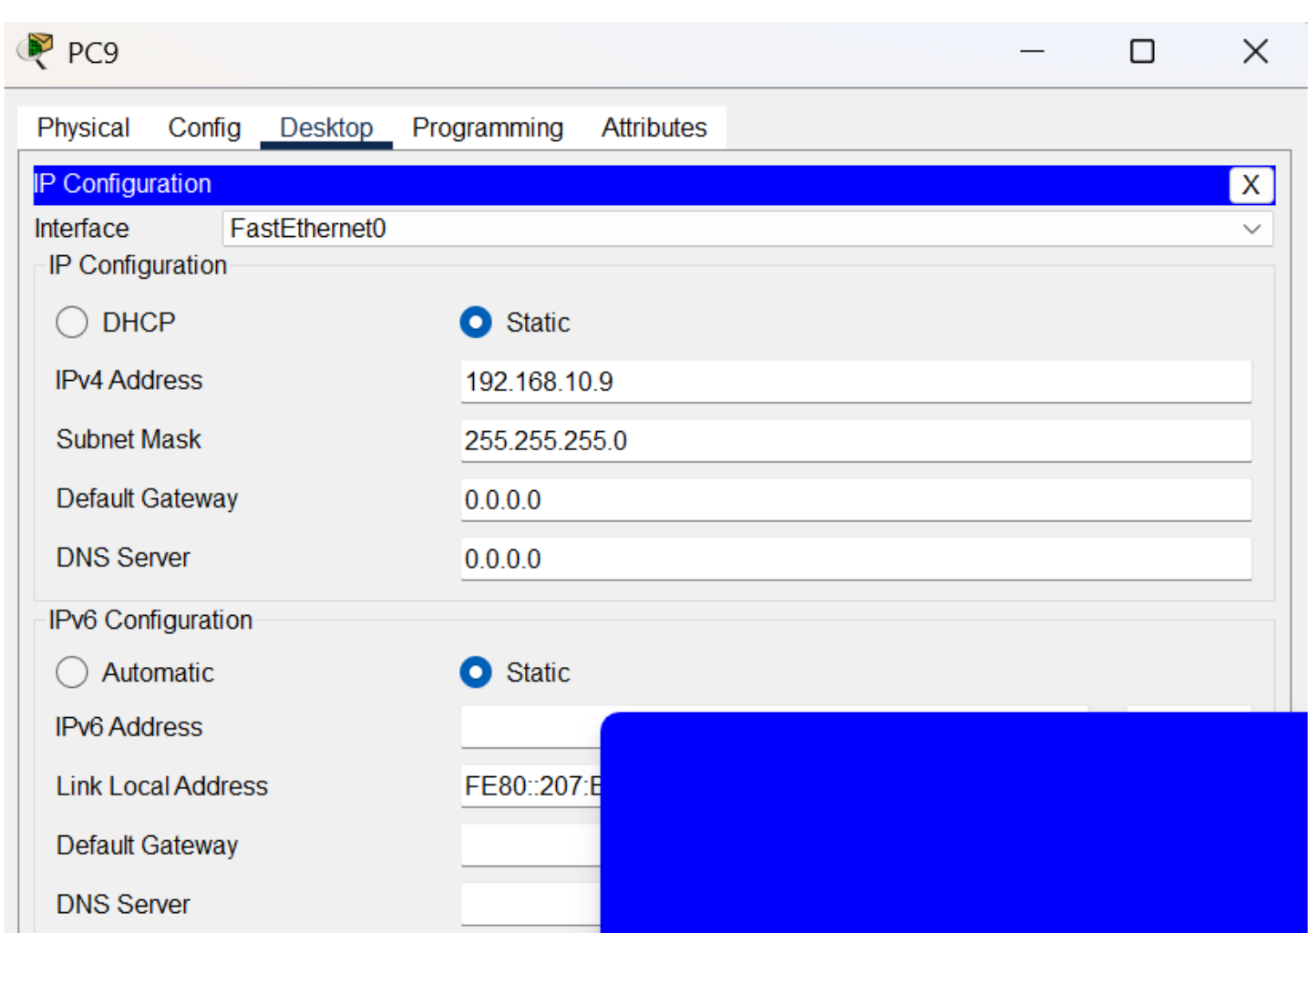
Figure 2. PC5 configured as 192.168.10.5/24. | Figure 3. PC9 configured as 192.168.10.9/24.

Verification point: The visible PC configuration screens confirm the 192.168.10.0/24 addressing scheme and show no Layer 3 gateway configured for this Layer 2-only lab.

2. Rapid PVST+ Configuration
Rapid PVST+ was enabled on Switch2, Switch3, Switch4, and Switch5. The same global configuration command is used on each switch, followed by saving the running configuration.
enable
configure terminal
spanning-tree mode rapid-pvst
end
write memory

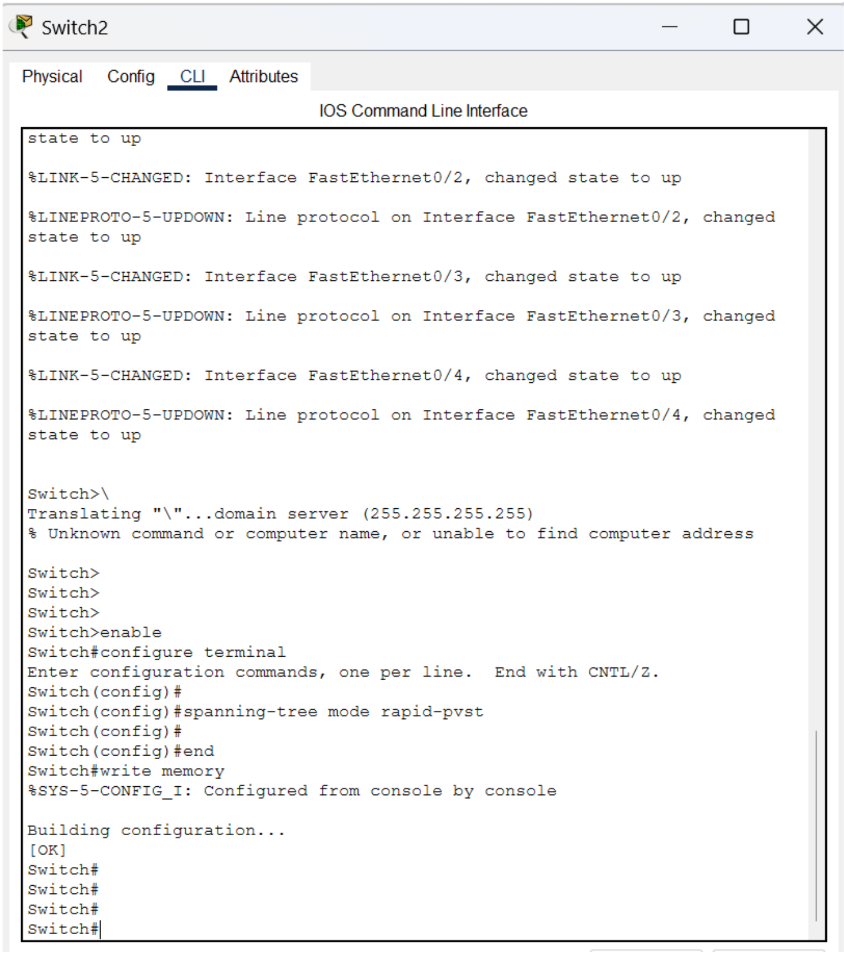 | 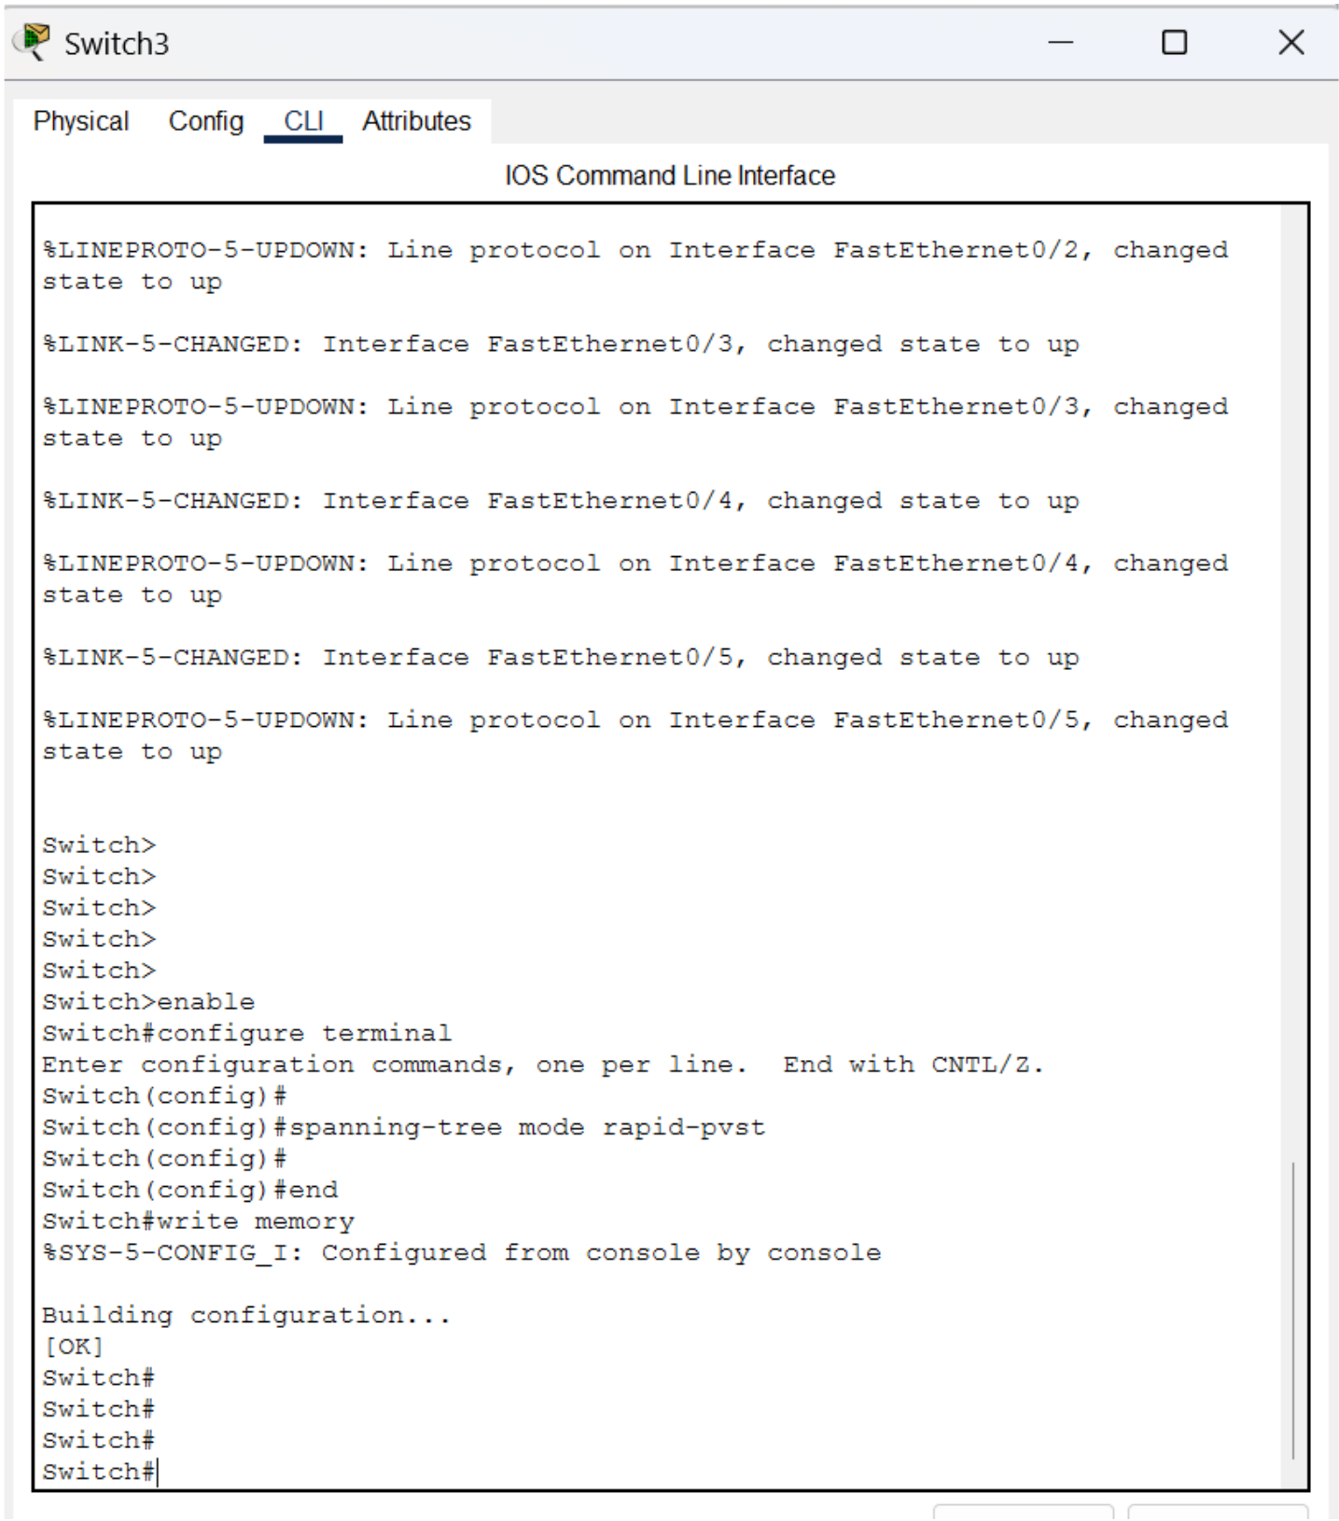
Figure 4. Switch2 Rapid PVST+ configuration. | Figure 5. Switch3 Rapid PVST+ configuration.

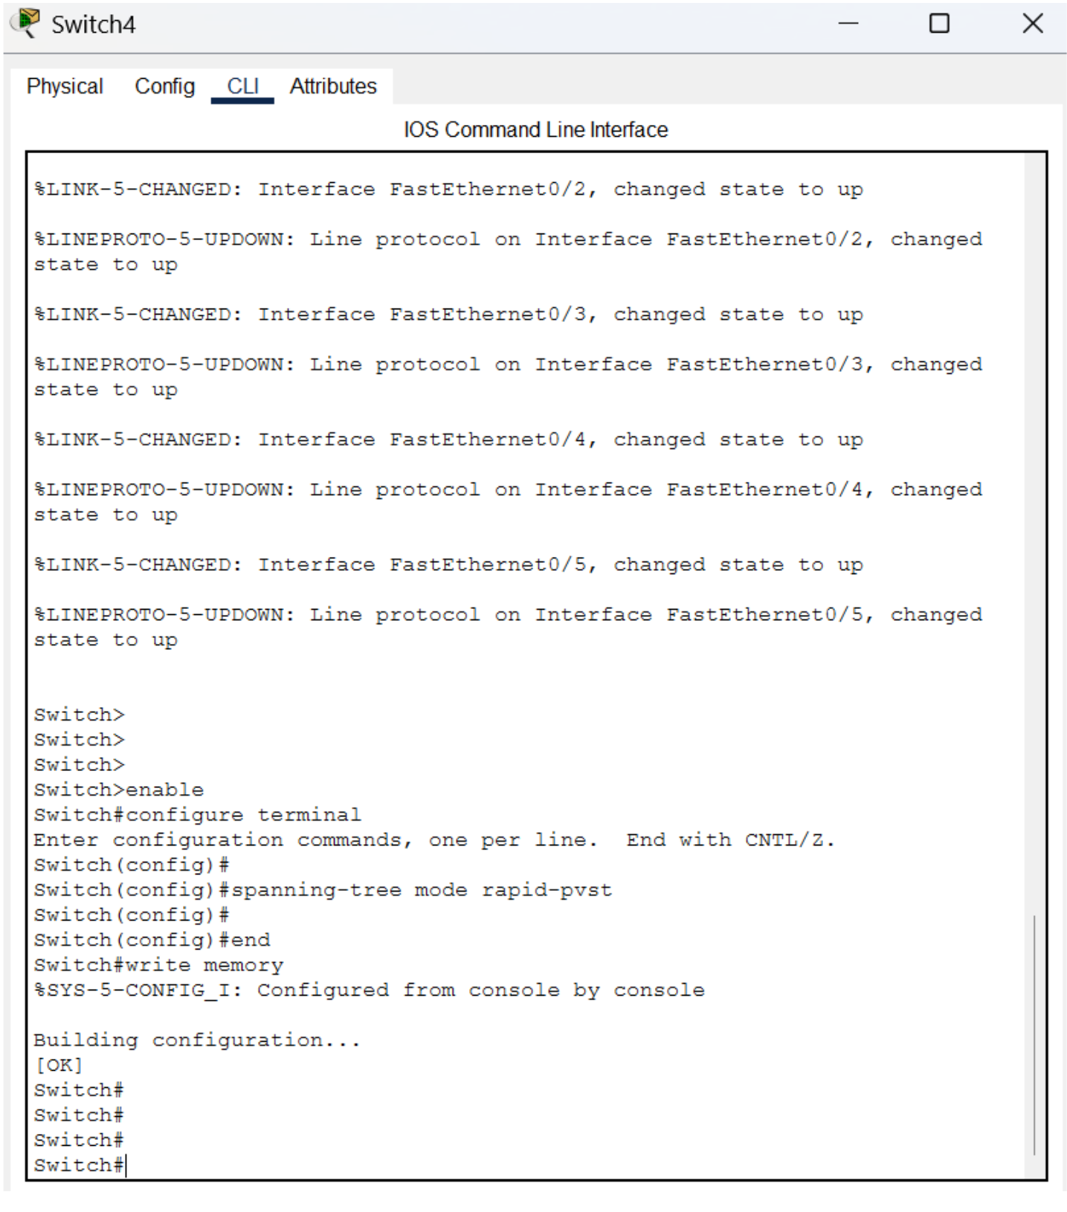 | 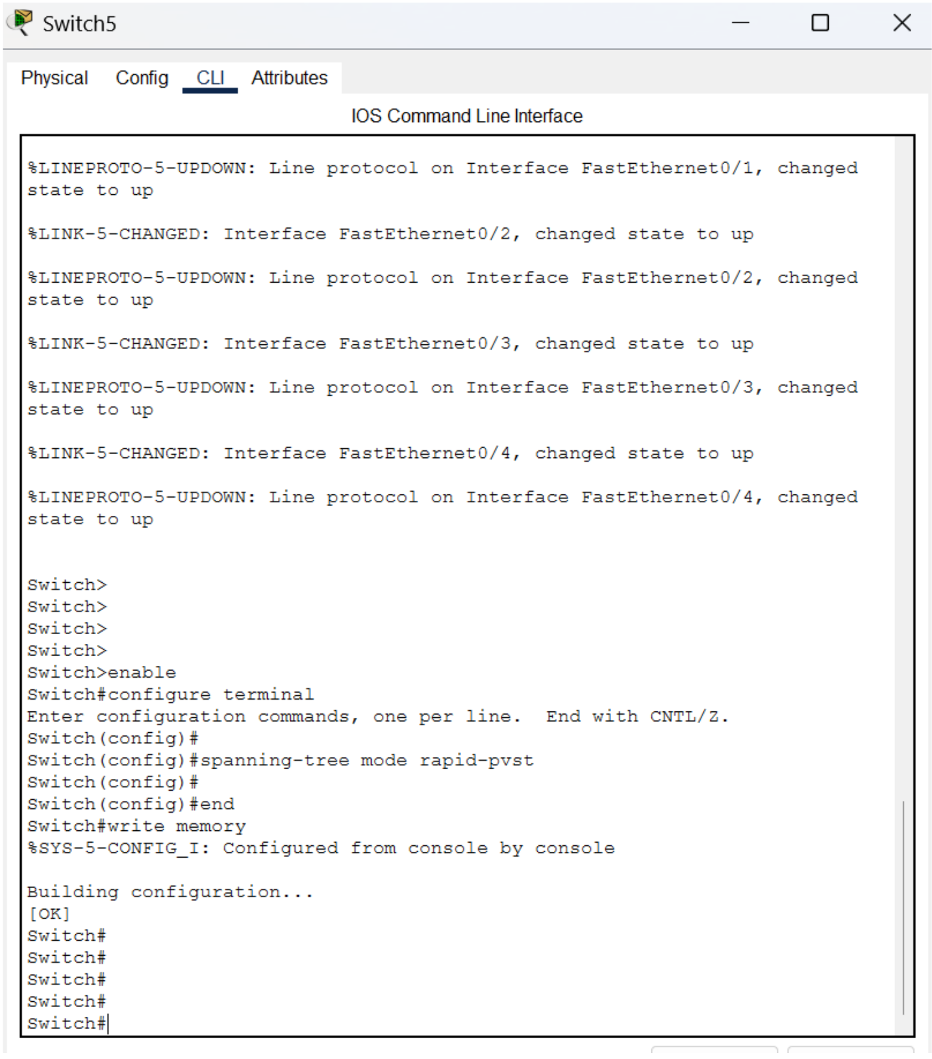
Figure 6. Switch4 Rapid PVST+ configuration. | Figure 7. Switch5 Rapid PVST+ configuration.

This configuration changes the spanning-tree mode from the default behavior to Rapid PVST+, allowing the redundant physical links to be managed as a loop-free logical topology.

3. Root Bridge and Backup Root Selection
The lab intentionally controls the spanning-tree hierarchy instead of allowing the root bridge to be selected only by default bridge values.

Switch2 - Primary root bridge
Switch2 is configured as the primary root bridge for VLAN 1:
spanning-tree vlan 1 root primary
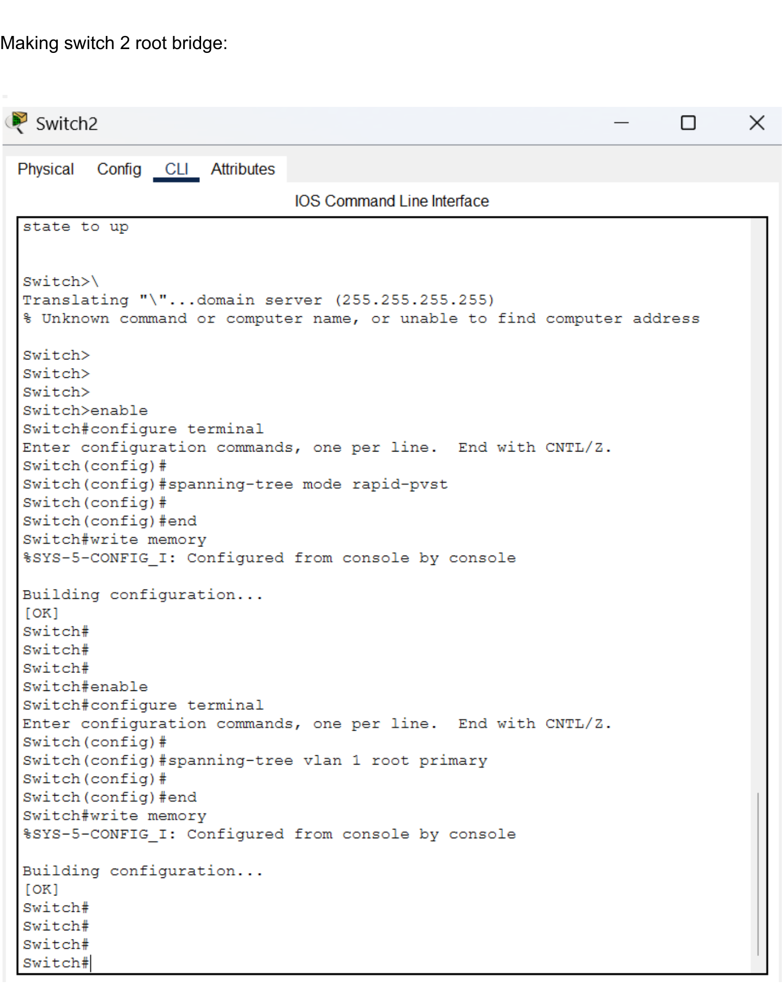
Figure 8. Switch2 configured as the VLAN 1 primary root bridge.

Switch3 - Secondary root bridge
Switch3 is configured as the secondary root bridge for VLAN 1:
spanning-tree vlan 1 root secondary
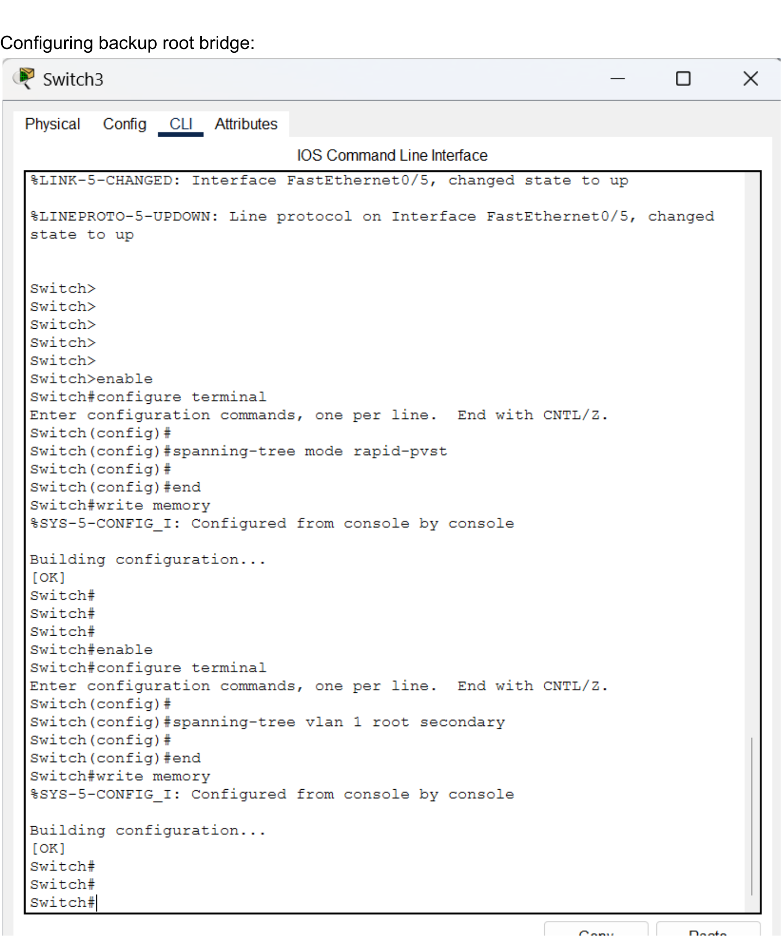
Figure 9. Switch3 configured as the VLAN 1 secondary root bridge.

4. Spanning-Tree Verification
The `show spanning-tree` output on Switch3 confirms that Rapid Spanning Tree is active for VLAN 1 and that the redundant topology has been reduced to a loop-free forwarding state.
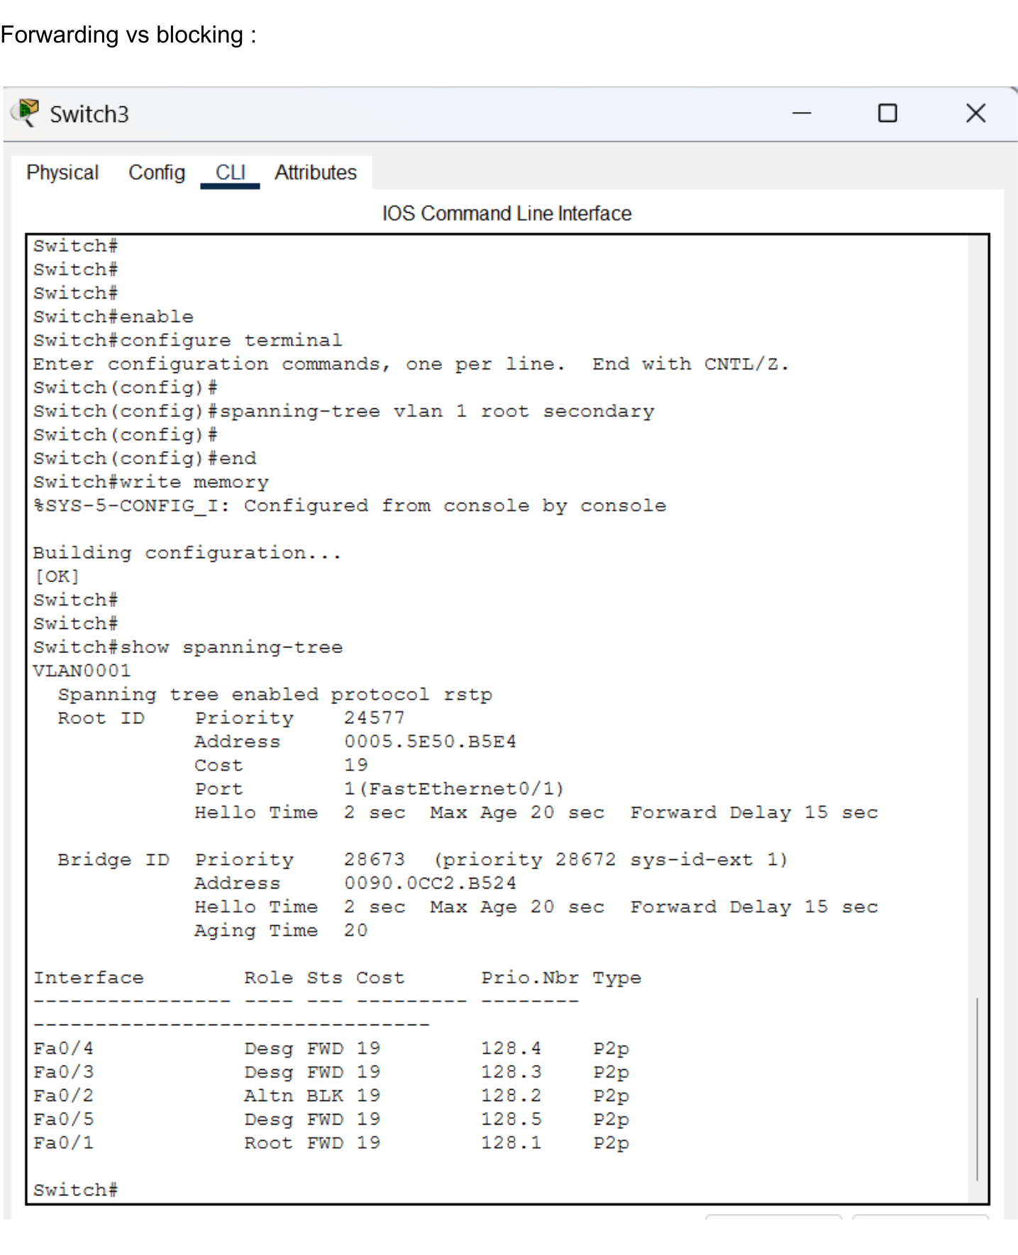
Figure 10. Switch3 spanning-tree state for VLAN 1.
Interface | Role | State | Interpretation
Fa0/1 | Root | FWD | Best path from Switch3 toward the root bridge.
Fa0/2 | Alternate | BLK | Redundant path held out of forwarding to prevent a Layer 2 loop.
Fa0/3 | Designated | FWD | Forwarding on this segment.
Fa0/4 | Designated | FWD | Forwarding on this segment.
Fa0/5 | Designated | FWD | Forwarding on this segment.
Key result: The Alternate/BLK state on Fa0/2 is expected. It is evidence that spanning tree detected redundant Layer 2 paths and prevented a switching loop while keeping an alternate path available.

5. End-to-End Connectivity Testing
ICMP echo testing was used to verify that PCs connected through different switches could communicate across the partial-mesh topology.
Test | Destination | Observed Result | Status
PC5 -> PC12 | 192.168.10.12 | Initial attempt timed out; repeated ping returned 4/4 replies with 0% loss. | PASS on repeat
PC7 -> PC5 | 192.168.10.5 | 4/4 replies received; 0% packet loss. | PASS
PC11 -> PC5 | 192.168.10.5 | 4/4 replies received; 0% packet loss. | PASS

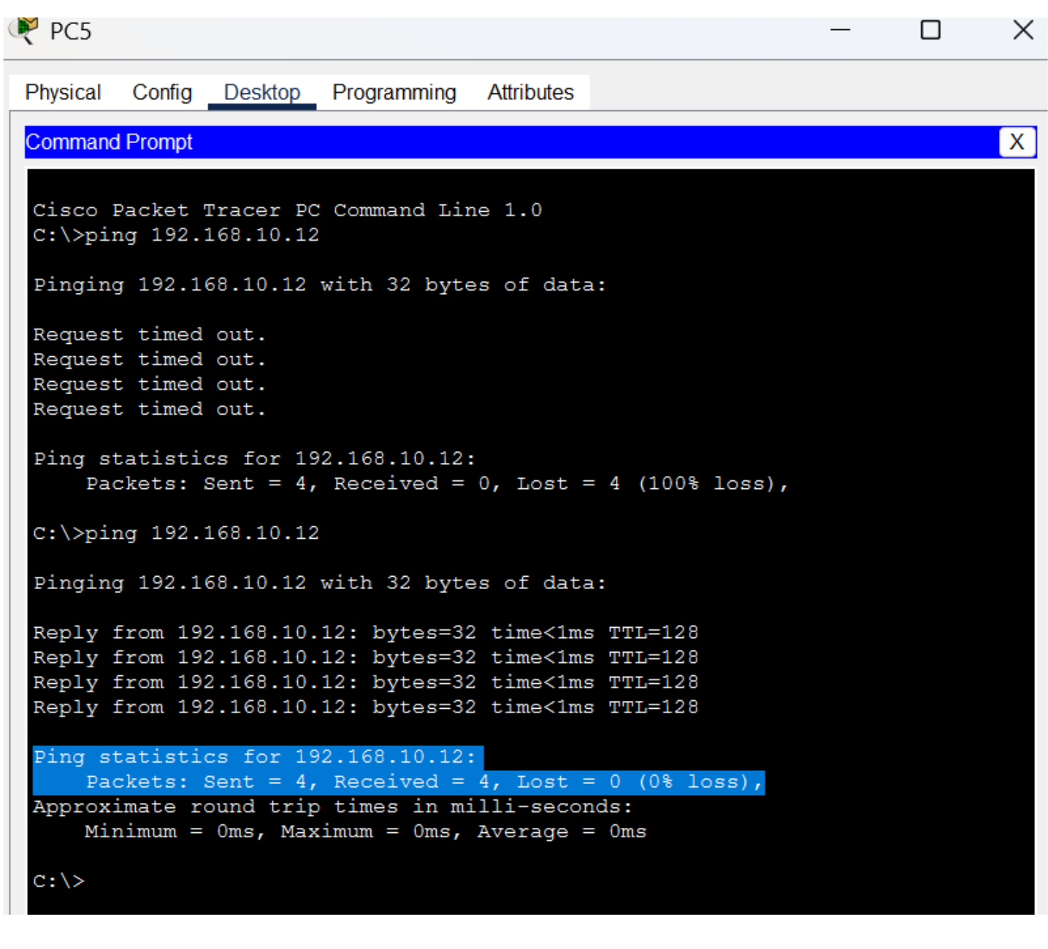
Figure 11. PC5 ping test to PC12 (192.168.10.12). The repeated test succeeds with 0% packet loss.
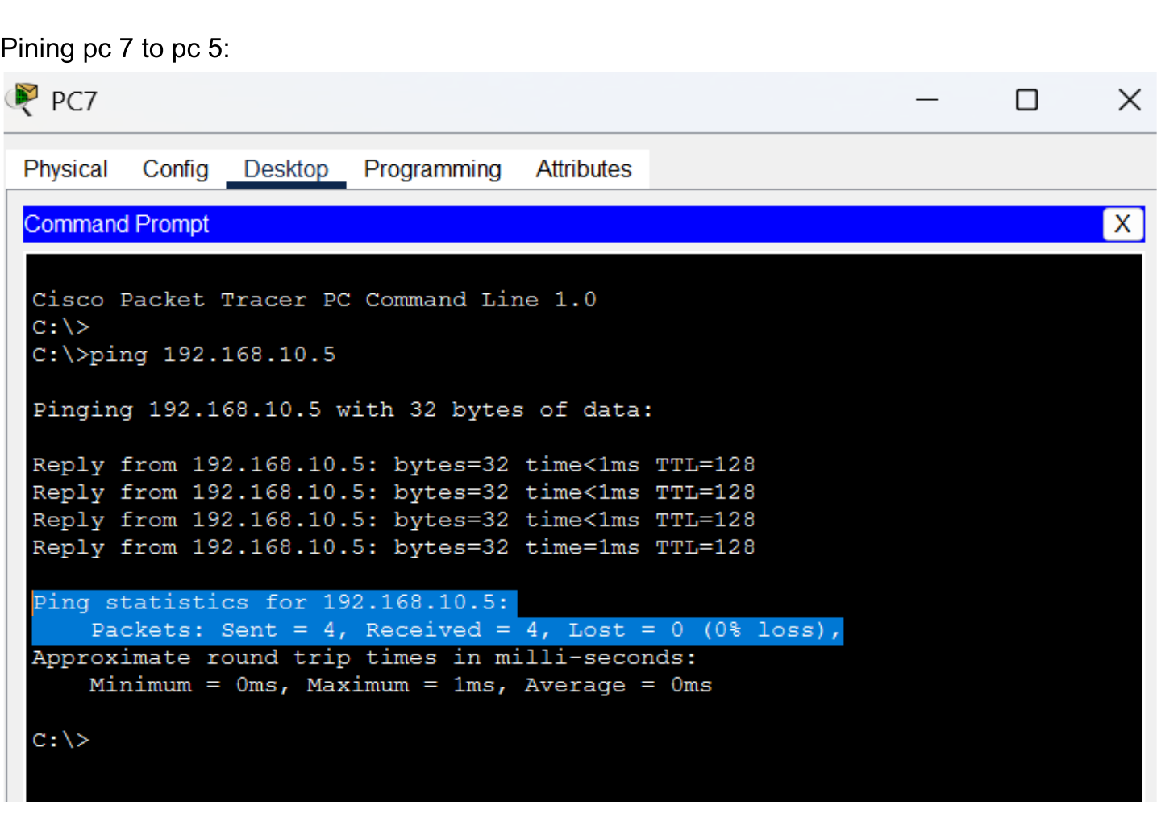 | 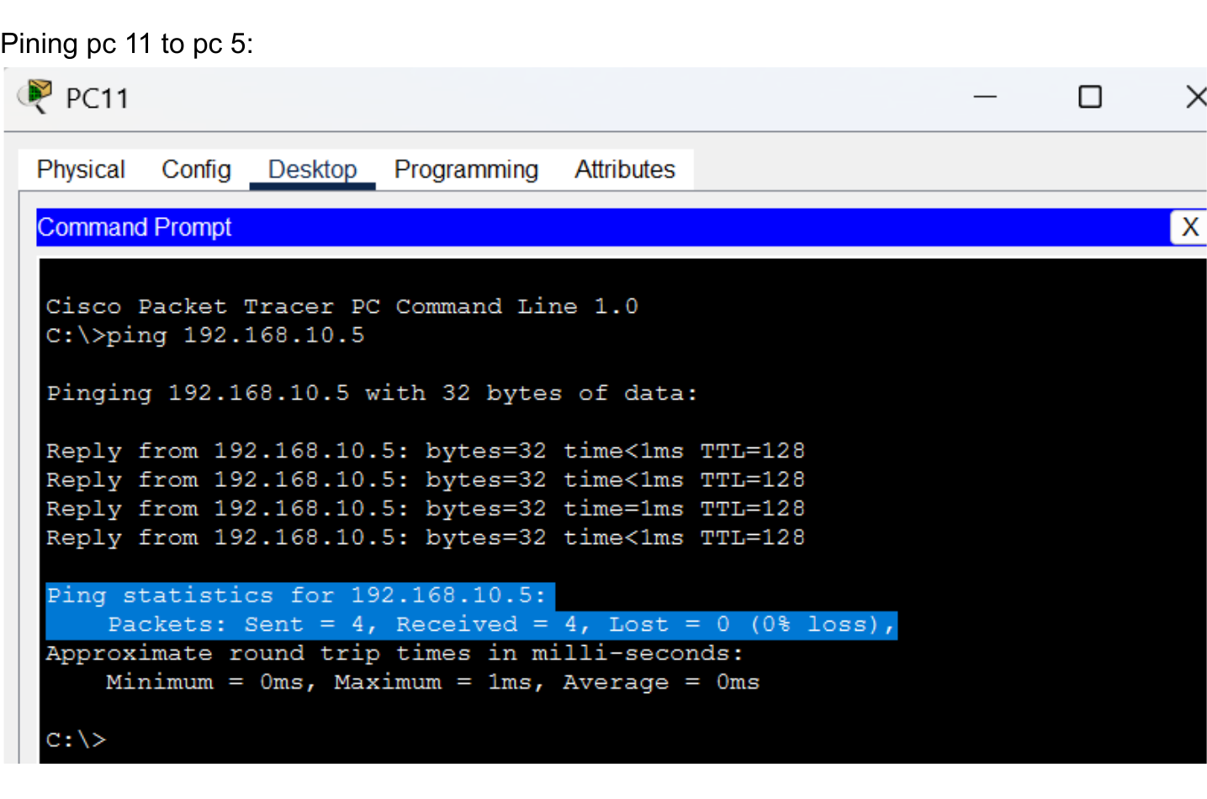
Figure 12. PC7 successfully pings PC5. | Figure 13. PC11 successfully pings PC5.

6. Results and Conclusion
The completed lab demonstrates a functioning partial-mesh Layer 2 network using four Cisco 2960-24TT switches and eight end devices. The physical design provides multiple inter-switch paths without creating a full mesh.
- Rapid PVST+ was enabled on all four switches.
- Switch2 was deliberately configured as the VLAN 1 primary root bridge.
- Switch3 was configured as the VLAN 1 secondary root bridge.
- Spanning-tree verification on Switch3 showed Fa0/1 as the root forwarding port and Fa0/2 as an alternate blocked port.
- Static IPv4 addressing in the 192.168.10.0/24 subnet allowed hosts on different switches to communicate.
- PC7 and PC11 successfully reached PC5 with 0% packet loss; the repeated PC5-to-PC12 test also completed with 0% packet loss.
Conclusion: The lab successfully verifies the core purpose of a partial-mesh LAN: redundant physical connectivity with loop prevention. Rapid PVST+ selects a safe forwarding topology while maintaining alternate paths that can be used if the active topology changes.

