CISCO PACKET TRACER LAB REPORT
Switched Ethernet Ring Topology
VLAN 10 segmentation, 802.1Q trunking, STP root bridge selection, and ICMP troubleshooting
Lab objective: Building and verifying an eight-switch Ethernet ring topology in Cisco Packet Tracer. The lab demonstrates redundant Layer 2 paths, VLAN 10 access/trunk design, Spanning Tree Protocol loop prevention, deliberate root bridge selection, and end-to-end connectivity troubleshooting.
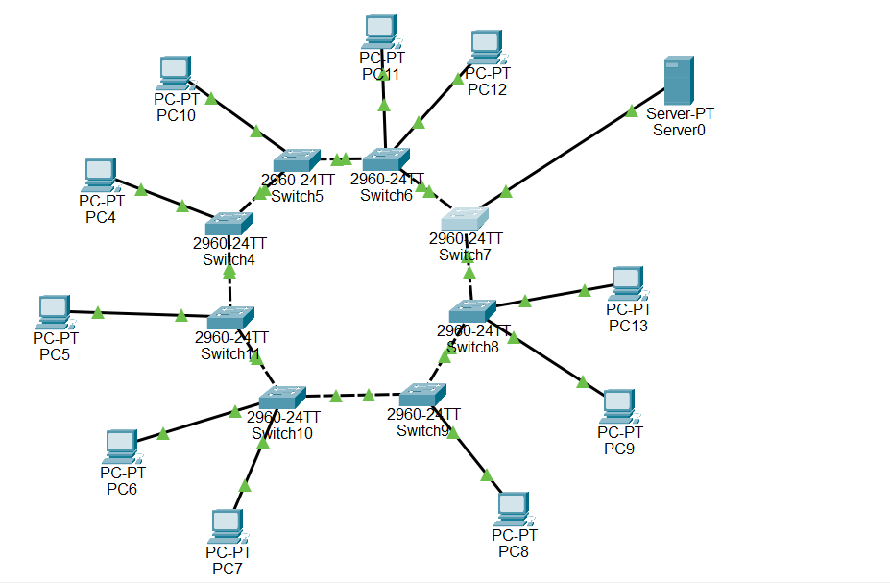
Figure 1. Completed physical ring topology using eight Cisco 2960-24TT switches, ten PC-PT endpoints, and one Server-PT endpoint.
The switch fabric forms a closed Layer 2 ring: Switch4-Switch5-Switch6-Switch7-Switch8-Switch9-Switch10-Switch11-Switch4. Each switch has redundant reachability to the rest of the LAN because traffic can potentially travel in either direction around the ring.
A closed Ethernet ring also creates a switching-loop risk. STP is therefore required to produce a loop-free logical topology while preserving the physical redundancy for recovery after a path change.

1. Network Design and IPv4 Addressing
All end devices use the 192.168.10.0/24 subnet so the lab can focus on Layer 2 switching, VLAN membership, trunking, and spanning-tree behavior. No router is present, so a default gateway is not required for same-subnet communication.
Device | IPv4 Address | Subnet Mask | Default Gateway
PC4 | 192.168.10.4 | 255.255.255.0 (/24) | None / 0.0.0.0
PC5 | 192.168.10.5 | 255.255.255.0 (/24) | None / 0.0.0.0
PC6 | 192.168.10.6 | 255.255.255.0 (/24) | None / 0.0.0.0
PC7 | 192.168.10.7 | 255.255.255.0 (/24) | None / 0.0.0.0
PC8 | 192.168.10.8 | 255.255.255.0 (/24) | None / 0.0.0.0
PC9 | 192.168.10.9 | 255.255.255.0 (/24) | None / 0.0.0.0
PC10 | 192.168.10.10 | 255.255.255.0 (/24) | None / 0.0.0.0
PC11 | 192.168.10.11 | 255.255.255.0 (/24) | None / 0.0.0.0
PC12 | 192.168.10.12 | 255.255.255.0 (/24) | None / 0.0.0.0
PC13 | 192.168.10.13 | 255.255.255.0 (/24) | None / 0.0.0.0
Server0 | 192.168.10.100 | 255.255.255.0 (/24) | None / 0.0.0.0
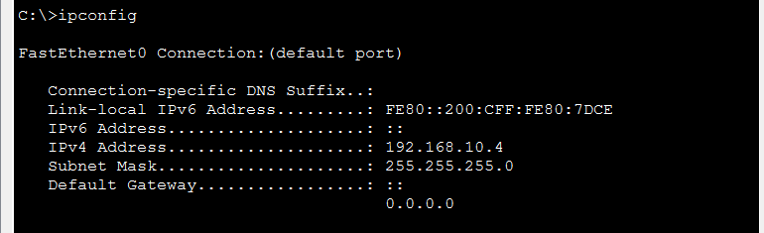
Figure 2. PC4 IP configuration confirms 192.168.10.4/24 with no Layer 3 default gateway.
Verification point: PC4 is correctly addressed in the 192.168.10.0/24 network. The remaining hosts must use unique addresses in the same subnet for Layer 2-only communication.

2. VLAN 10 Access Configuration
VLAN 10, named CONTROL_NETWORK, is used as the common Layer 2 broadcast domain for the PCs and server. End-device-facing ports are configured as access ports; PortFast is applied only to edge ports connected to endpoints.
enable
configure terminal
vlan 10
name CONTROL_NETWORK
exit
interface fa0/3
switchport mode access
switchport access vlan 10
spanning-tree portfast
no shutdown
end
write memory
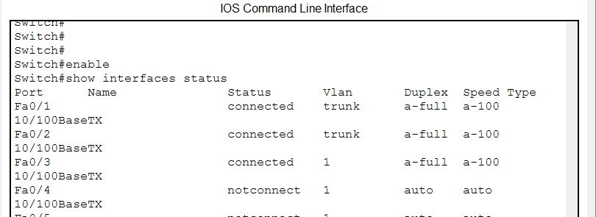 | 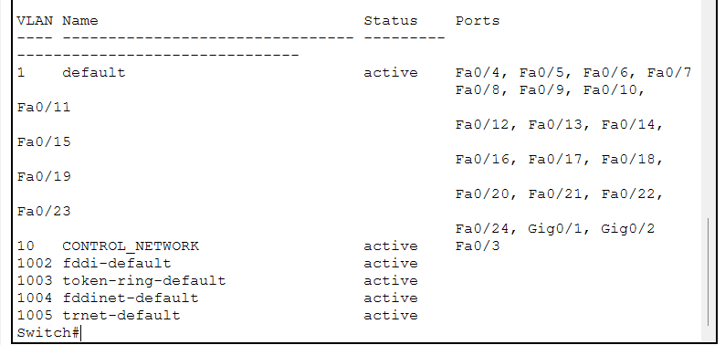
Figure 3. Switch4 interface status identifies Fa0/1 and Fa0/2 as ring trunks and Fa0/3 as the endpoint-facing port. | Figure 4. Switch4 VLAN brief confirms Fa0/3 assigned to VLAN 10 CONTROL_NETWORK.
The key design rule is separation of roles: endpoint ports operate as access VLAN 10 ports, while the two ring-facing interfaces on each switch operate as trunks. This prevents the access/trunk mismatch that was observed during initial troubleshooting.

3. 802.1Q Trunk Configuration
Every switch-to-switch link in the ring must carry VLAN 10. The inter-switch FastEthernet interfaces are therefore configured as IEEE 802.1Q trunks with VLAN 10 explicitly allowed.
enable
configure terminal
interface range fa0/1 - 2
switchport mode trunk
switchport trunk allowed vlan 10
no shutdown
end
write memory
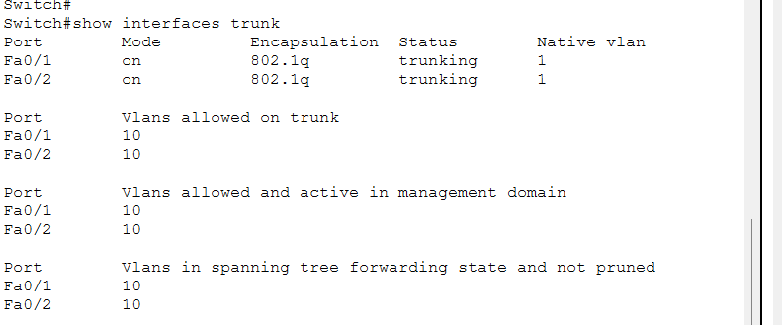
Figure 5. Switch4 show interfaces trunk output: Fa0/1 and Fa0/2 are trunking with native VLAN 1 and VLAN 10 allowed, active, and forwarding.
Key result: Switch4 provides verified continuity for VLAN 10 in both directions around the ring. The output also confirms that the native VLAN is 1 on both local trunk interfaces.

4. Root Bridge Selection
The spanning-tree hierarchy is controlled by deliberately selecting Switch7 as the root bridge for VLAN 10. Choosing a known root makes the forwarding topology predictable and simplifies troubleshooting.

Switch7 - Primary root bridge
Switch7 is configured as the primary root bridge for VLAN 10:
spanning-tree vlan 10 root primary
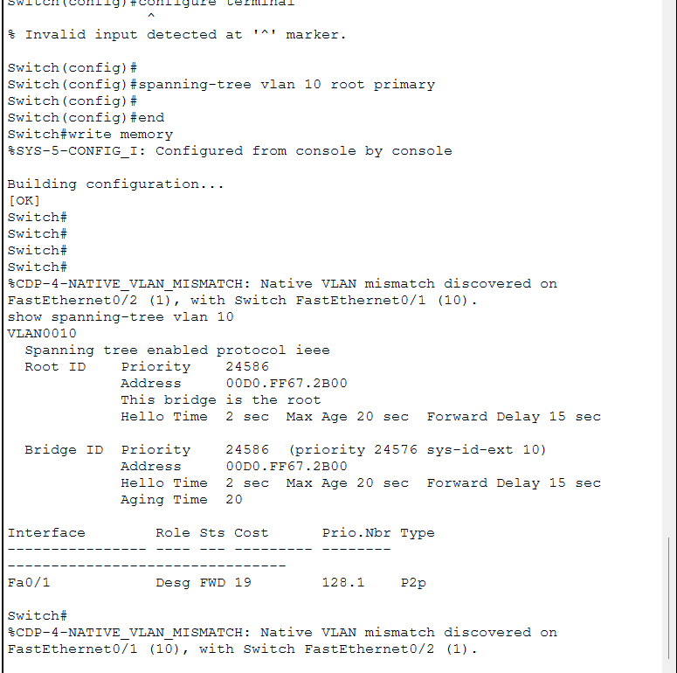
Figure 6. Switch7 root-bridge configuration and early spanning-tree verification. The output confirms "This bridge is the root" while also exposing a native VLAN mismatch that required correction.

5. Spanning-Tree Verification
The show spanning-tree vlan 10 output verifies the control-plane state for the ring. Switch7 reports itself as the root bridge, so its ring-facing interfaces are designated ports. During convergence, Fa0/2 briefly entered the learning state before reaching forwarding.
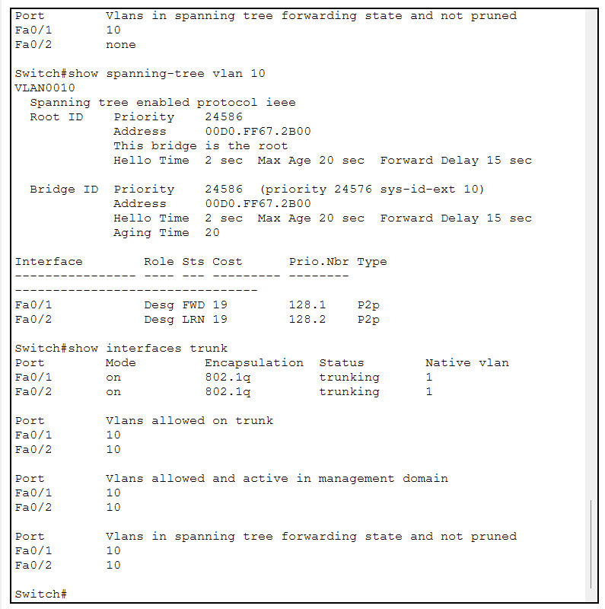
Figure 7. Switch7 spanning-tree and trunk verification for VLAN 10 after both ring-facing ports were configured as trunks.
Interface | Role | Observed State | Interpretation
Fa0/1 | Designated | FWD | Root-bridge port forwarding toward one side of the ring.
Fa0/2 | Designated | LRN -> FWD | Port progressed through STP convergence after trunk configuration.
Key result: The temporary LRN state is expected during STP convergence. The later trunk output shows VLAN 10 in the forwarding state on both Switch7 ring ports.

6. Native VLAN Mismatch Troubleshooting
CDP repeatedly reported a native VLAN mismatch on Switch7 because one side of a ring connection was operating as VLAN 10 access while the opposite side used native VLAN 1. This is a configuration asymmetry, not a physical-link failure.
%CDP-4-NATIVE_VLAN_MISMATCH:
Native VLAN mismatch discovered on FastEthernet0/1 (10),
with Switch FastEthernet0/2 (1).
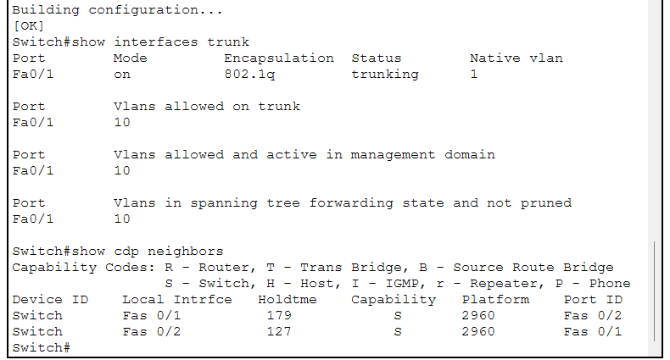 | 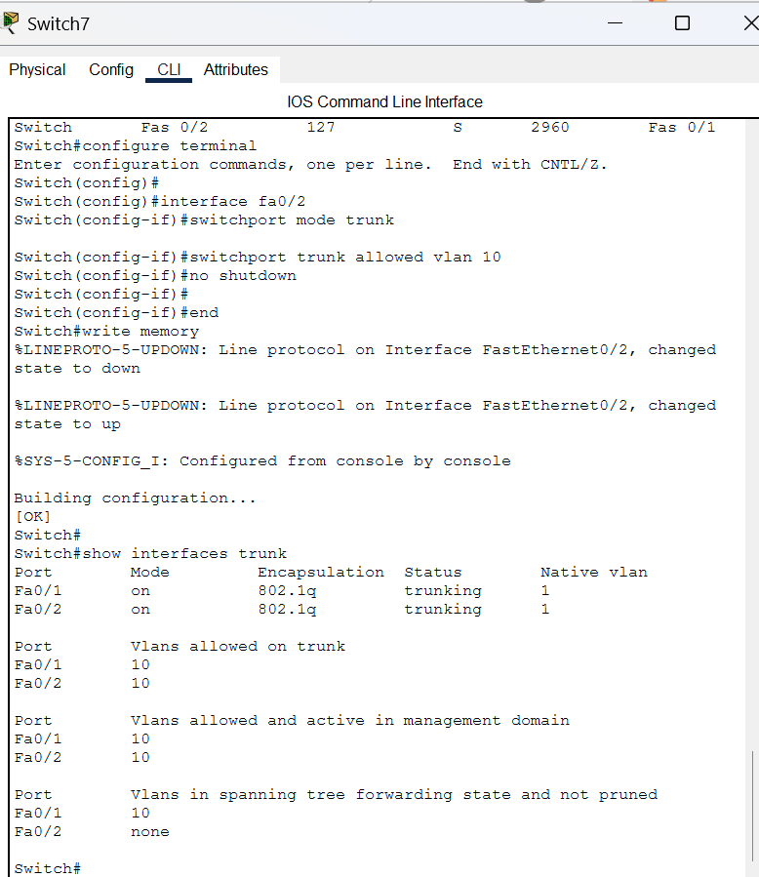
Figure 8. CDP neighbor output identifies Switch7 Fa0/1 and Fa0/2 as the two ring-facing interfaces. | Figure 9. Corrective configuration changes Fa0/2 to an 802.1Q trunk and allows VLAN 10.
Finding | Diagnosis | Corrective Action
Local VLAN 10 vs neighbor VLAN 1 | Access/trunk or native-VLAN inconsistency | Configure both ends of the inter-switch link as trunks.
Only one Switch7 trunk initially visible | Second ring port not yet trunking | Configure Fa0/2 with switchport mode trunk and allow VLAN 10.
STP port enters LRN after change | Normal convergence behavior | Wait for STP to transition the interface to forwarding.

7. End-to-End Connectivity Testing
ICMP echo testing was used to evaluate whether traffic could traverse the ring from PC4 to remote endpoints. At the latest captured test, PC4 could not reach PC13 or Server0, so final end-to-end connectivity remained under troubleshooting.
Test | Destination | Observed Result | Status
PC4 -> PC13 | 192.168.10.13 | 4 requests timed out; 100% packet loss. | FAIL - CHECK
PC4 -> Server0 | 192.168.10.100 | 4 requests timed out; 100% packet loss. | FAIL - CHECK
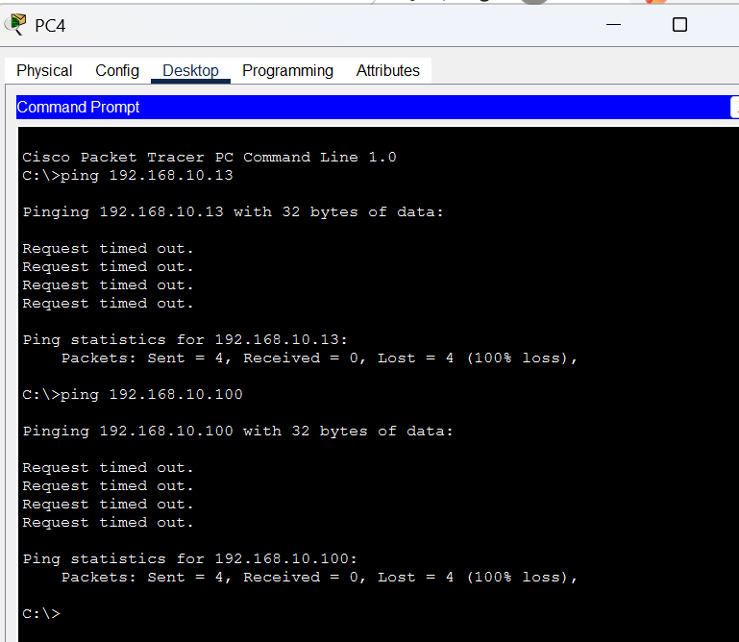
Figure 10. PC4 ICMP tests to PC13 and Server0 show 100% packet loss and identify the remaining end-to-end connectivity problem.
Interpretation: Because PC4 addressing and key trunks on Switch4/Switch7 were verified, the remaining fault domain includes the unverified intermediate ring switches and the access-VLAN membership/IP configuration of PC13 and Server0.

8. Verification Summary and Next Diagnostic Steps
The following commands provide a structured method for isolating the remaining connectivity fault without changing already verified configuration.
Command | Purpose | Current Evidence
show vlan brief | Verify VLAN 10 exists and endpoint ports are access members. | Switch4 confirms Fa0/3 in VLAN 10.
show interfaces trunk | Verify both ring links trunk VLAN 10. | Switch4 and Switch7 are verified.
show spanning-tree vlan 10 | Confirm root, port roles, and loop-free state. | Switch7 is root; Switch4 has a root forwarding port.
show cdp neighbors | Map each local ring port to the neighboring switch port. | Used successfully on Switch7.
show mac address-table dynamic | Confirm learned endpoint MAC addresses and forwarding direction. | Recommended for the next fault-isolation step.
 | 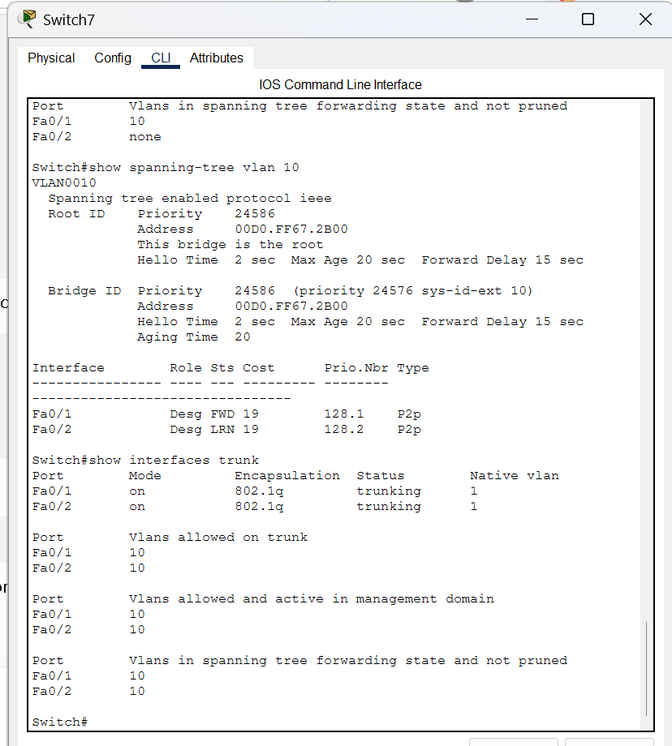
Figure 11. Switch4 trunk verification. | Figure 12. Switch7 root/trunk verification.
Next diagnostic sequence: Verify Fa0/1 and Fa0/2 as VLAN 10 trunks on Switch5, Switch6, Switch8, Switch9, Switch10, and Switch11; then verify the PC13 and Server0 switch ports as access VLAN 10 ports before repeating ICMP tests.

9. Results and Conclusion
The ring-topology lab demonstrates the configuration and troubleshooting workflow required for a redundant Layer 2 Ethernet network using Cisco 2960-24TT switches.
- An eight-switch physical ring was constructed with ten PCs and one server attached as endpoints.
- VLAN 10 (CONTROL_NETWORK) was created for endpoint communication, and Switch4 Fa0/3 was verified as an access VLAN 10 port.
- Switch4 Fa0/1 and Fa0/2 were verified as 802.1Q trunks carrying VLAN 10 in the spanning-tree forwarding state.
- Switch7 was deliberately configured and verified as the VLAN 10 STP root bridge.
- A CDP native-VLAN mismatch was diagnosed as an inter-switch access/trunk inconsistency, and Switch7 Fa0/1/Fa0/2 were standardized as VLAN 10 trunks.
- The most recent PC4-to-PC13 and PC4-to-Server0 ICMP tests still showed 100% loss, so end-to-end acceptance testing remains pending.
Conclusion: The core ring architecture, VLAN 10 design, trunking on the verified switches, and STP root-bridge behavior are functioning as intended. The remaining engineering task is to validate VLAN 10 continuity across every intermediate switch and the endpoint access ports, then repeat ICMP testing until successful end-to-end communication is demonstrated.
This troubleshooting sequence reflects a practical Layer 2 methodology: verify endpoint addressing, confirm access VLAN membership, validate trunk continuity, inspect STP roles/states, use CDP to map neighbors, and only then isolate the final forwarding break.

