CISCO PACKET TRACER LAB REPORT
Switched Ethernet Star Topology
VLAN Segmentation, IPv4 Connectivity & Layer 2 Verification
Cisco Catalyst 2960-24TT | VLAN 10 | 192.168.10.0/24 | ARP / ICMP | MAC Learning
Developed by: Sam Khalaf
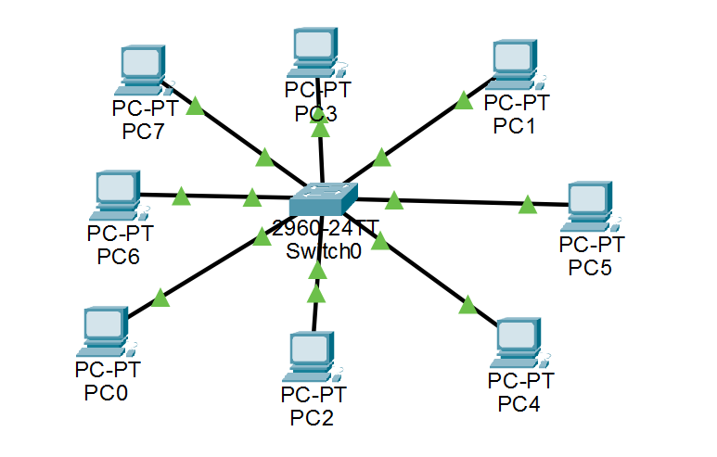
Figure 1. Eight-endpoint Ethernet star topology centered on a Cisco 2960 switch.
LAB RESULT  PASS | TESTED CONNECTIVITY  4/4 replies | PACKET LOSS  0%
Networking Fundamentals / CCNA Practice Lab
September 10, 2026

1. Lab Overview & Objectives
A concise design-and-verification report for a basic switched LAN.
This lab builds a small Ethernet LAN using a physical star topology: every endpoint connects directly to one central Cisco Catalyst 2960-24TT switch. The logical design places all eight PCs in VLAN 10 (CONTROL_NETWORK) and the 192.168.10.0/24 IPv4 subnet so that end devices can communicate locally without a router.

Objectives
- Build and validate an eight-node star topology in Cisco Packet Tracer.
- Create VLAN 10 (CONTROL_NETWORK) and assign FastEthernet0/1 through FastEthernet0/8 as access ports.
- Configure static IPv4 addressing within a single /24 subnet.
- Verify Layer 2 and Layer 3 reachability using switch status commands and ICMP ping tests.
- Observe dynamic MAC address learning and relate ARP/ICMP behavior to switched Ethernet operation.

Network Inventory
Component | Quantity | Role | Interface / Media
Cisco 2960-24TT | 1 | Central Layer 2 switch | Fa0/1-Fa0/8
PC-PT endpoints | 8 | Traffic sources / destinations | FastEthernet0
Copper Ethernet links | 8 | Point-to-point access links | Straight-through

Addressing & VLAN Plan
Device | Switch Port | VLAN | IPv4 Address | Subnet Mask
SW-STAR SVI | VLAN 10 | 10 | 192.168.10.2 | 255.255.255.0
PC0 | Fa0/1 | 10 | 192.168.10.10 | 255.255.255.0
PC1 | Fa0/2 | 10 | 192.168.10.11 | 255.255.255.0
PC2 | Fa0/3 | 10 | 192.168.10.12 | 255.255.255.0
PC3 | Fa0/4 | 10 | 192.168.10.13 | 255.255.255.0
PC4 | Fa0/5 | 10 | 192.168.10.14 | 255.255.255.0
PC5 | Fa0/6 | 10 | 192.168.10.15 | 255.255.255.0
PC6 | Fa0/7 | 10 | 192.168.10.16 | 255.255.255.0
PC7 | Fa0/8 | 10 | 192.168.10.17 | 255.255.255.0
Design note
Default gateway is not required for the tested PC-to-PC communication because all endpoints are in the same VLAN and IPv4 subnet. Routing becomes necessary only when traffic must cross into a different IP network.

2. Physical & Logical Topology
Centralized access switching with a single broadcast domain for the lab.
Figure 2. Packet Tracer topology: eight PCs connected directly to Switch0.
The physical layout is a classic star: each PC has an independent Ethernet link to the central switch. A single host-link failure affects only that host; however, the switch is the central point of connectivity and therefore the principal point of failure in this basic design.

How a frame crosses the star
PC0  192.168.10.10 | -> | SW-STAR  Layer 2 forwarding | -> | PC1  192.168.10.11

Expected Layer 2 Behavior
- The switch learns source MAC addresses from incoming Ethernet frames and associates them with physical switch ports.
- Known unicast traffic is forwarded only toward the port associated with the destination MAC address.
- When a destination MAC address is unknown, ARP and other broadcasts are flooded within the VLAN so the destination can be discovered.
- Control traffic such as STP BPDUs or CDP advertisements may appear in Packet Tracer Simulation mode even when no user ping is being generated.
Why VLAN 10 matters
All active PC ports were assigned to the same access VLAN, creating one controlled Layer 2 broadcast domain for this lab. The VLAN designation is logical; the star topology describes the physical connection pattern.

3. Switch Configuration
Creation of VLAN 10, access-port assignment, PortFast and management SVI.
enable
configure terminal
hostname SW-STAR
no ip domain-lookup
vlan 10
name CONTROL_NETWORK
exit
interface range fastEthernet 0/1 - 8
switchport mode access
switchport access vlan 10
spanning-tree portfast
no shutdown
exit
interface vlan 10
ip address 192.168.10.2 255.255.255.0
no shutdown
exit
end
copy running-config startup-config
Configuration 1. Core switch configuration used for the star-topology lab.
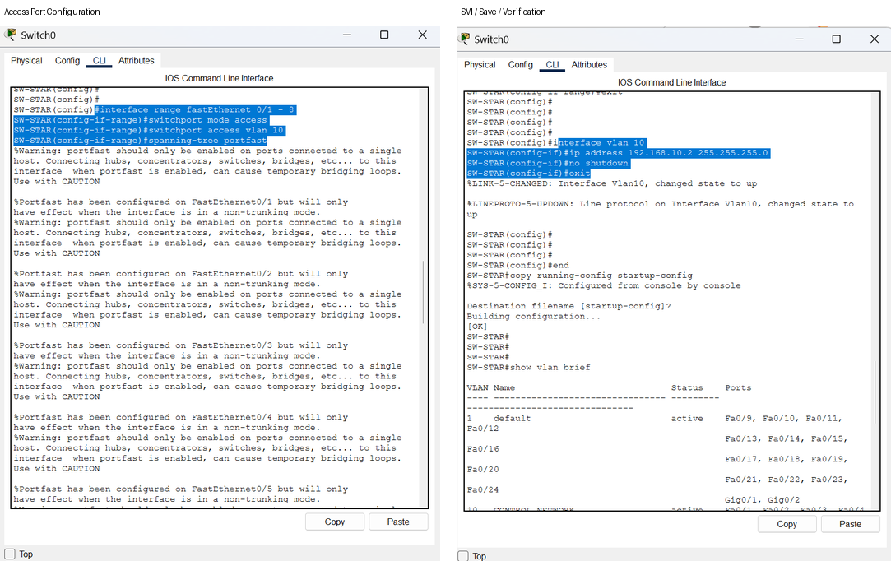
Figure 3. Access-port configuration and VLAN 10 SVI / configuration save evidence.

Configuration Rationale
- switchport mode access forces the endpoint-facing interfaces to operate as access ports rather than trunks.
- switchport access vlan 10 places Fa0/1-Fa0/8 in CONTROL_NETWORK.
- spanning-tree portfast allows host-facing ports to transition to forwarding rapidly; it does not disable STP.
- interface vlan 10 provides a switch management SVI at 192.168.10.2/24.

3.1 Switch Verification
The switch was validated after configuration to confirm VLAN membership and interface state before performing host-to-host testing.
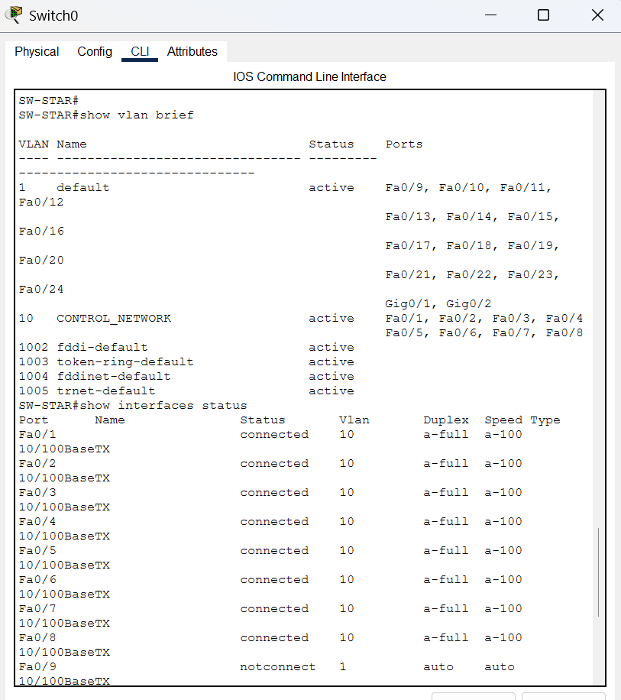
Figure 4. show vlan brief and show interfaces status verification.

Observed State
- VLAN 10 (CONTROL_NETWORK) is active.
- Fa0/1 through Fa0/8 are assigned to VLAN 10 and show connected status.
- Unused FastEthernet ports remain in the default VLAN and show notconnect.
- The running configuration was saved to startup configuration for persistence.

Verification Commands
show vlan brief
show interfaces status
show ip interface brief
show mac address-table
show running-config

4. End-Device IPv4 Configuration
Static addressing places every endpoint in the same 192.168.10.0/24 network.
Each PC was configured with a unique IPv4 address and a /24 subnet mask (255.255.255.0). The screenshots below show representative endpoint configurations for PC0, PC1 and PC7.
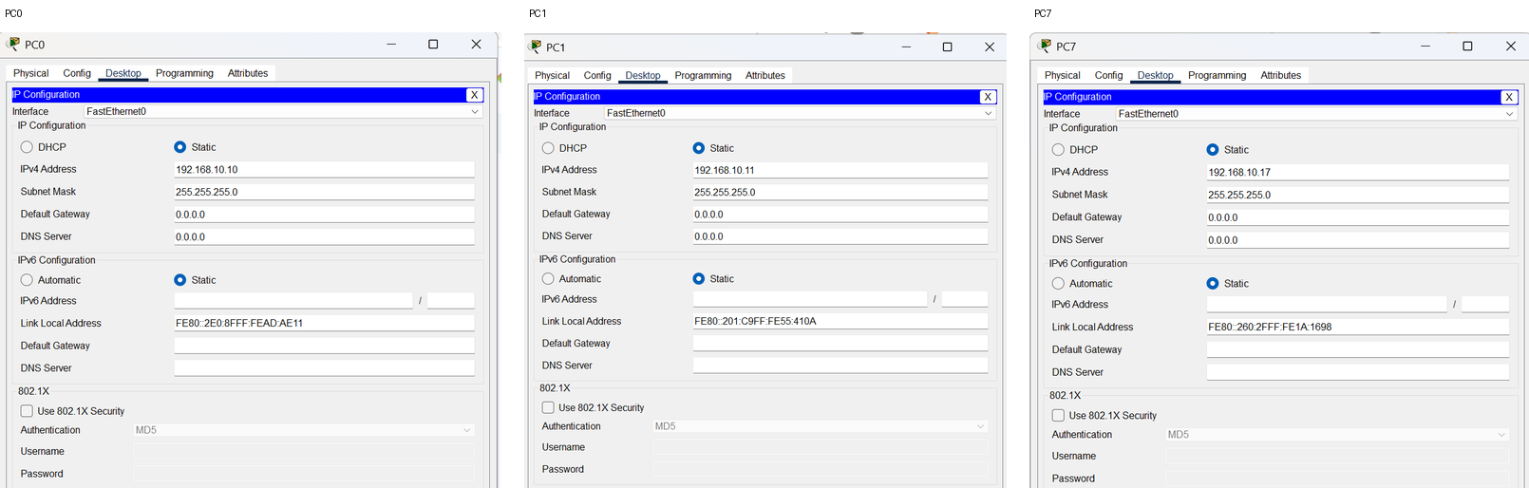
Figure 5. Representative static IPv4 configurations: PC0, PC1 and PC7.

Addressing Logic
- Network address: 192.168.10.0/24.
- Valid host addresses used by the PCs: 192.168.10.10 through 192.168.10.17.
- Switch management address: 192.168.10.2/24.
- All hosts share the same subnet mask, so local traffic is delivered directly at Layer 2 after address resolution.
Common configuration error to avoid
Every endpoint must use a unique IPv4 address. Duplicate addresses, mismatched subnet masks, or a PC connected to a port outside VLAN 10 would prevent reliable communication.

5. Connectivity Verification
ICMP testing confirms end-to-end reachability through the switch.
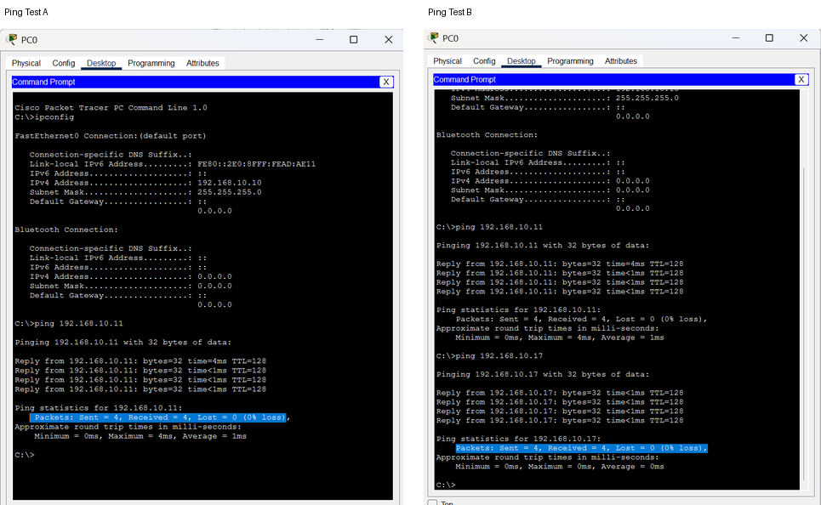
Figure 6. Command Prompt evidence showing successful ICMP reachability tests.

Observed Results
Source | Destination | Sent | Received | Loss
PC0 | PC1 (192.168.10.11) | 4 | 4 | 0%
PC0 | PC7 (192.168.10.17) | 4 | 4 | 0%

What Happens Before the Ping
If PC0 does not yet know the destination MAC address, it first uses ARP to map the destination IPv4 address to a Layer 2 address. After ARP resolution, ICMP Echo Request and Echo Reply messages can be carried in Ethernet frames through the switch.
1 | ARP Request | PC0 -> Switch -> VLAN 10 broadcast
2 | ARP Reply | Destination PC -> Switch -> PC0
3 | ICMP Echo Request | PC0 -> Switch -> destination PC
4 | ICMP Echo Reply | Destination PC -> Switch -> PC0
Simulation-mode practice
For a clean Packet Tracer packet-flow view, filter the event list to ARP and ICMP. Background switch protocols such as STP or CDP can otherwise dominate the event list and appear as envelopes even though they are not the user-generated ping test.

6. Layer 2 Validation & MAC Learning
The forwarding database confirms that the switch learned active endpoints dynamically.
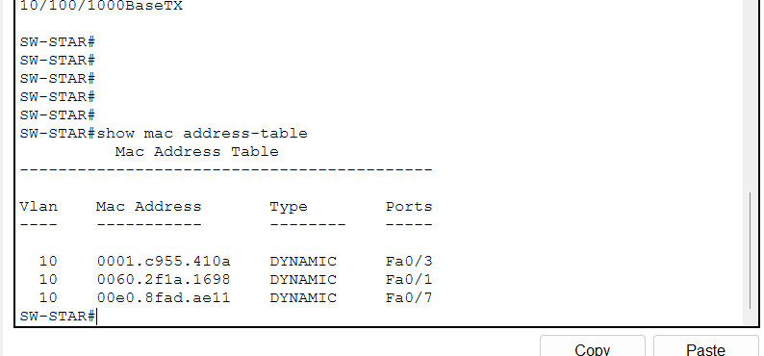
Figure 7. Dynamic MAC address-table evidence after traffic generation.

Observed Dynamic MAC Entries
VLAN | MAC Address | Type | Learned Port
10 | 0001.c955.410a | DYNAMIC | Fa0/3
10 | 0060.2f1a.1698 | DYNAMIC | Fa0/1
10 | 00e0.8fad.ae11 | DYNAMIC | Fa0/7
The MAC table does not need to list every connected PC immediately. A Layer 2 switch learns a device only after receiving frames sourced from that device. The entries shown therefore demonstrate successful dynamic source-MAC learning on VLAN 10.

Verification Interpretation
- VLAN 10 is active and Fa0/1-Fa0/8 are assigned to CONTROL_NETWORK.
- Connected access ports operate at the expected VLAN membership and link state.
- Dynamic MAC entries show that the switch is building its forwarding table from observed traffic.
- The successful pings and MAC table together validate both IP reachability and Layer 2 forwarding behavior.

7. Findings, Engineering Relevance & Conclusion
Summary of what was validated and how the concepts extend to real managed networks.

Key Findings
- The eight-node physical star topology was successfully established around one Cisco 2960 switch.
- All endpoint-facing interfaces were placed in VLAN 10 and the switch management SVI was configured on the same /24 subnet.
- Representative ICMP tests completed with 4 packets sent, 4 received and 0% loss.
- The switch dynamically learned source MAC addresses and associated them with access ports, confirming normal Layer 2 forwarding behavior.
- Packet Tracer simulation can expose both user traffic (ARP/ICMP) and background control traffic (for example STP/CDP); filters help isolate the protocol under study.

Controls / Industrial Networking Relevance
The same Ethernet fundamentals apply when a managed switch connects PLCs, HMIs, SCADA servers, engineering workstations, gateways and BMS/EMS devices. VLAN membership, IP addressing, ARP, MAC learning, interface status and structured troubleshooting are foundational skills for diagnosing communication problems in switched automation networks.

Recommended Next Lab
- Separate endpoints into multiple VLANs (for example Engineering, Controls and SCADA).
- Add a router or multilayer switch and configure inter-VLAN routing.
- Configure 802.1Q trunk links between switches.
- Add redundant switching paths and observe STP root/blocked-port behavior.
- Use ACLs and basic network segmentation to restrict traffic between logical zones.
Conclusion
The lab achieved its objective: a functional switched Ethernet star network was configured, segmented into VLAN 10, addressed within one IPv4 subnet, and validated through ICMP reachability and dynamic MAC learning. The result provides a solid base for more advanced CCNA and industrial-control networking labs.

Appendix A - Quick Validation Checklist
Check | Expected State | Result
Physical links | Fa0/1-Fa0/8 connected | PASS
VLAN membership | Fa0/1-Fa0/8 in VLAN 10 | PASS
IPv4 subnet | All PCs in 192.168.10.0/24 | PASS
ICMP reachability | Replies between tested endpoints | PASS
MAC learning | Dynamic MAC-to-port entries present | PASS
Configuration persistence | Running config copied to startup config | PASS

